Table of Contents
Welcome 2
Guidance 3
Scheduling Procedures 4
Grade Forgiveness and Credit Recovery ……….….7
Graduation Requirements 8
NCAA Requirements 10
Bright Futures Requirements 11
Dual Enrollment Criteria 12
TCC Dual Enrollment Courses ……………………….13
AP Courses 14

Subject Area Courses
Language Arts 15
Language Arts Electives 16
Math 17
Science 19
Social Science 20
Social Science Electives 22
Fine and Performing Arts 23
World Language 25
Physical Education 25
Intensive and Required Courses 26
General Electives 26
College and Career Programs of Study 27
ACCESS 30

WELCOME TO 2022-2023!

Hello, Students and Parents!
We are very excited to begin another year as the War Eagle family. Many conversations and considerations have been devoted to the creation of this 2022-2023 Curriculum Guide, and we hope you will read it carefully. Please feel free to contact us with any questions or concerns.
We consider it a privilege to work with your students and hope that their time at Wakulla High School is both a rewarding and edifying experience.
Please consult our website at https://whs.wakullaschooldistrict.org/ regularly for important information and updates.

Looking forward to a great year,

Wakulla High School Administrative Team

Sabrina “Michele” Falk Johnny Graham
Principal Assistant Principal of Discipline

Timothy Wheeler Frankie Harvey
Assistant Principal of Instructional Services Assistant Principal of Discipline

Logan Crouch
Assistant Principal of Student Services

NOTICE OF NONDISCRIMINATION
The Wakulla County School District does not discriminate on the basis of race, color, national origin, gender, age, or disability in admission to its programs, services, or activities, in access to them, in treatment of individuals, or in any aspect of their operations. Admission into academic and elective courses as well as CTE programs is based on the demonstration of student readiness as evidenced through student GPA and prerequisite course completion specific to a program of study. The Wakulla County School District assures that the lack of English language skills will not be a barrier to student participation in academic, elective, or CTE programs. The Wakulla County School District also does not discriminate in its hiring or employment practices.
This notice is provided as required by Title VI of the Civil Rights Act of 1964, Section 504 of the Rehabilitation Act of 1973, Title IX of the Education Amendments of 1972, the Age Discrimination Act of 1975, and the Americans with Disabilities Act of 1990, the Boys Scout of America Equal Access Act and the Florida Educational Equity Act. Questions, complaints, or requests for additional information regarding these laws may be forwarded to Angela Walker, Director of Human Resources.
Lori Sandgren, Director of Human Resources; 69 Arran Road, Crawfordville, FL 32327 — 850.926.0065, — lori.sandgren@wcsb.us

WAKULLA HIGH SCHOOL GUIDANCE

Wakulla High School students are assigned a grade level counselor to provide academic advisement in the areas of course selection, remediation needs, accelerated mechanisms, graduation requirements, postsecondary school admission requirements, and study skills. These counselors attend not only to academic concerns, but to the needs of the individual through counseling and advising consultations that seek to assist students with social and emotional issues that may impact student achievement, the student’s learning environment, and school performance. Counselors work with administrators, teachers, and staff to meet student needs by serving as the conduit for communication between students and parents and school employees.

GUIDANCE COUNSELORS
Grade Level Counselors

9th Grade  Transition and Student Support | 10th Grade  Senior Sponsor 504 Designee | 11th Grade  Scholarships | 12th Grade  Risk Intervention & Graduation | All Grade Levels  RtI & Dual Enrollment
Susan Hutchins | Jillian Solburg | Jennifer Edwards | Amanda Camper | Jessica Mapes

High school is an unparalleled experience. The courses you take in high school greatly impact future college and career opportunities. It is important to get to know your curriculum guide and to make informed, thoughtful choices regarding your schedule. Parents and students should attend the WHS parent nights and open houses. These opportunities are designed to showcase the educational pathways and special program opportunities available to students. They are also opportunities to speak with guidance counselors and teachers regarding program entrance requirements, pre-requisites for Honors, AP, and Dual-Enrollment, and general scheduling questions.
Students should discuss and plan their schedule with their parents. Parents should ensure their student’s planned schedule follows the scheduling procedures and reflects courses needed for graduation. Any questions and concerns should be addressed with a guidance counselor or program teacher prior to registration.

SCHEDULING PROCEDURES

READ the curriculum guide carefully.
REVIEW the list of graduation requirements and determine which requirements have been met and which courses need to be taken next year. Consider courses which need to be repeated because of lost credit.
TALK to your parents and teachers about course selections and appropriate academic levels as determined by your classroom teacher.
SELECT courses that will correspond to or complement your goals for the future. Course selection represents a commitment on the part of the student and parent to complete the schedule of classes chosen.
SCHEDULE CHANGE PROCEDURES
Please be aware of the schedule change procedure when course selections are made. Schedule change requests must take place during our August Open House and no later than the first week of school. All requests will be reviewed during the first five days of school. All students who register for a full credit course are expected to remain in the course for both semesters as scheduling is done annually.
Requests for schedule changes will be considered for the following reasons:
- Scheduling error (for example, Geometry was requested and student received Algebra II)
- Failure to complete a prerequisite course or requirement
- Graduation or college requirement omitted from schedule
- Special programs requiring unique schedules (for example, Band, Academy courses, Exceptional Student Education, Advanced Placement, or Dual-enrollment)
- Summer school course or credit recovery completion
- Duplicate course
- Blank period schedule
- Limits in class-size or class availability
According to the Wakulla County Student Progression Plan, if a student is enrolled in an Honors or AP course, the student may not drop the course until the end of the first semester and ONLY if ALL of the following conditions exist:
- Student has a grade of D or F,
- Completion of a parent conference during each grading period,
- Demonstration of the student seeking consistent academic assistance, AND
- space available in a comparable class.

COURSE LEVEL RIGOR
Regular
These courses are designed for in-depth instruction that challenges students. These classes are suitable for all students.
Expected homework: approximately 20-30 minutes day/course.
Honors
These courses are designed for self-motivated students who wish to pursue a more challenging curriculum while in high school.
Grades of A or B in a regular or honors pre-requisite (other pre-requisites may apply)
FSA and EOC scores of 4 or above and/or teacher recommendation
A solid work ethic and good attendance
Expected homework: approximately 30-45 minutes day/course
Advanced Studies (Advanced Placement)
These college-level courses are designed for highly motivated students who wish to pursue potential college credit in high school.
Grades of A or B in a regular or honors pre-requisite (other pre-requisites may apply)
FSA and EOC scores of 4 or above and/or teacher recommendation
A solid work ethic and excellent attendance
Expected homework: approximately 30-60 minutes day/course
Career and Technical Education
These courses are designed to prepare students for employment and/or post-secondary education in a career of their choice.
Dual Enrollment
These courses are designed for highly motivated students who have met the requisite requirements to participate in courses through TCC or FSU, earning both high school and college course credit simultaneously.

COURSE WEIGHTING
Grade | Percent | Non-Weighted Grade Point Value | Honors Weighted Grade Point Value | AP, and Dual Enrollment Weighted Grade Point Value
A | 90-100 | 4 | 4.5 | 5
B | 80-89 | 3 | 3.5 | 4
C | 70-79 | 2 | 2.5 | 3
D | 60-69 | 1 | 1.5 | 2
F | 0-59 | 0 | 0 | 0

- An additional weight of .5 is added to Honors courses for grade point average (GPA) calculation.
- An additional weight of 1.0 is added to Advanced Placement and Dual Enrollment courses for GPA calculation.

PROMOTION REQUIREMENTS
- 9th Grade to 10th Grade: A minimum of four (4) credits earned in Grade 9 and a 1.0 GPA.
- 10th Grade to 11th Grade: A minimum of eleven (11) total credits earned in Grades 9 and 10 including at least one (1) English, one (1) mathematics, one (1) science, one (1) required social studies credit, and a 1.5 GPA.
- 11th Grade to 12th Grade: A minimum of seventeen (17) total credits earned in Grades 9 through 11 of which at least nine (9) fulfill course requirements. At least two (2) credits must be earned in English, two (2) mathematics, two (2) science, one (1) required social studies and a 2.0 GPA.
- Second Year Seniors: When a student, after completing one full year with classification as a senior, lacks the 24 credits or the 2.0 GPA required for graduation, he/she may return to Wakulla High School as a second year senior on a part-time basis to complete the requirements for graduation.

Students may graduate from high school earlier than four (4) years if they have met all graduation requirements. This may be done through early admissions, advanced study, dual enrollment or other means agreed to by the School Board.

SELECTION OF HONOR GRADUATES
Honor Court:
The cumulative weighted grade point averages of seniors are ranked at the end of the first semester of the student’s senior year. The top senior becomes Valedictorian, the second senior becomes Salutatorian, and the next eighteen seniors become members of the Honor Court. In order to be Valedictorian, Salutatorian or a member of the Honor Court, a student must have been in attendance at Wakulla High School for the entire second semester of their year prior to graduation and the entire first semester of their senior year. In addition, they must have earned all credits required for graduation by the end of the regular school year, not counting summer school or unfinished virtual classes.
Graduation Honors:
Graduation honors will be awarded according to unweighted grade point averages as follows:
Cum Laude – 3.25-3.49
Magna Cum Laude – 3.50 – 3.74
Summa Cum Laude – 3.75 – 4.00

GRADE FORGIVENESS
State law requires a cumulative 2.0 GPA to graduate. Forgiveness policies for required courses will be limited to replacing a grade of "D" or "F", or the equivalent, with a grade of "C" or higher, or its equivalent, earned subsequently in the same or comparable course. Forgiveness policies for elective courses will be limited to replacing a grade of "D" or "F", or the equivalent, with a grade of "C" or higher, or its equivalent, earned subsequently in a comparable course. These restrictions on forgiveness do not apply to middle school students having taken high school courses. The only exception to these forgiveness policies shall be made for a student in the middle grades who takes any high school course for high school credit and earns a grade of “C,” “D,” or “F”. In such case, the district forgiveness policy must allow the replacement of the grade with a grade of “C” or higher earned subsequently in the same or comparable course.
Any course credit not replaced according to the district's forgiveness policy will be included in the calculation of the cumulative GPA required for graduation. All courses and grades must be included on the student’s transcript.
If an “F” is received in a course required for graduation, the student is strongly encouraged to repeat the course as soon as possible. Please note that failure to earn a full credit in a year-long course required for graduation may keep a student from going on to a higher course in that subject area.
A student is cautioned NOT to repeat courses for which credit has already been received. No credit will be awarded the second time. Courses in which one earns a C or higher may NOT be retaken to improve a grade.
Students may earn grade forgiveness in an on-campus Credit Recovery course, virtual instruction from home, or summer school.
The district’s Student Progression Plan contains updated information on grade forgiveness. The document can be accessed at www.wakullaschooldistrict.org.

CREDIT RECOVERY
This computer based program offers forgiveness credit in academic courses required for graduation. To be eligible, the student must have previously earned a “D” or “F” in a required core course. Students should be able to work independently and read information on their own while working on the computer. Courses are self-paced. Interested students should contact their guidance counselor.

COMMUNITY SERVICE PERIOD OPTION
(JUNIORS AND SENIORS ONLY)
Only students on track for graduation with a minimum of 14 credits, a passing score on the Algebra EOC and FSA- ELA, and a cumulative unweighted GPA of 2.50, will be allowed to register for a Community Service period. Requests for a Community Service should be made at the time of registration and the completed notarized parent form MUST be returned BEFORE the Community Service will be scheduled. Final approval for 11th and 12th graders making a request will occur after FSA scores and GPA’s are received during the summer. Requests for a Community Service period will not be considered after the beginning of each semester.

GRADUATION REQUIREMENTS 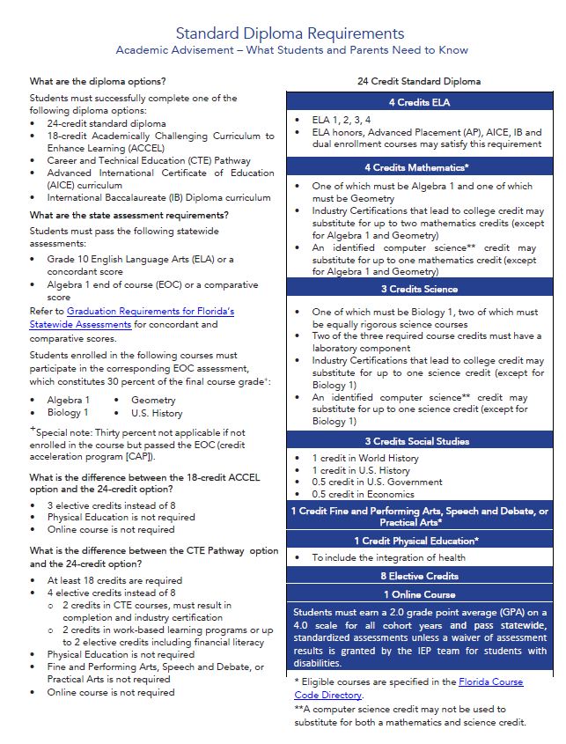

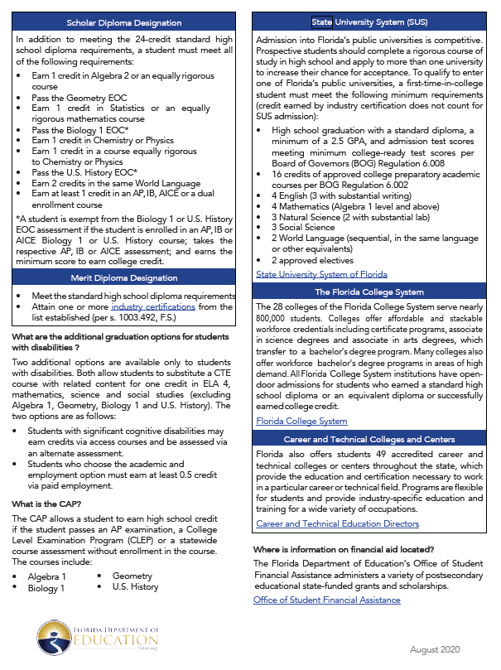

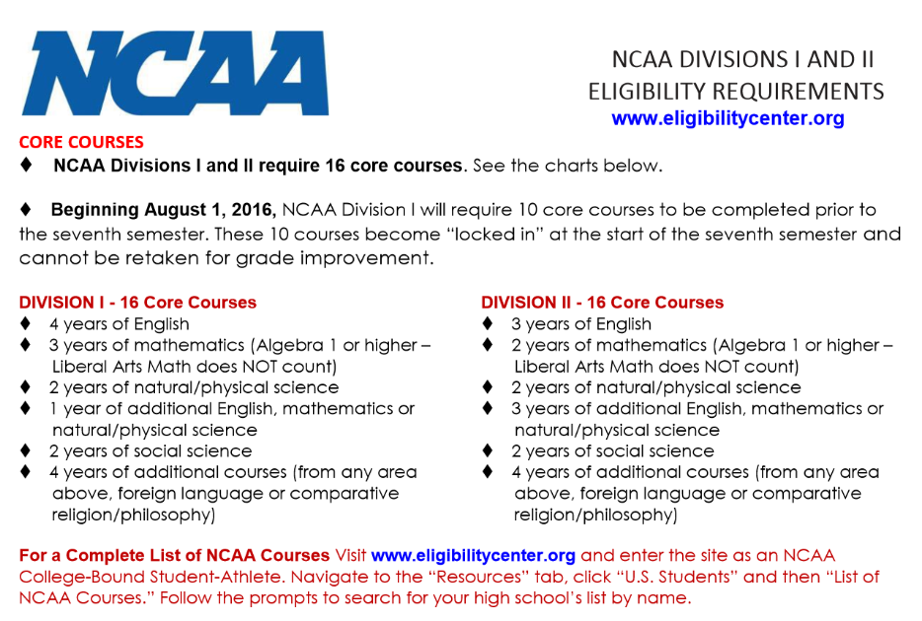
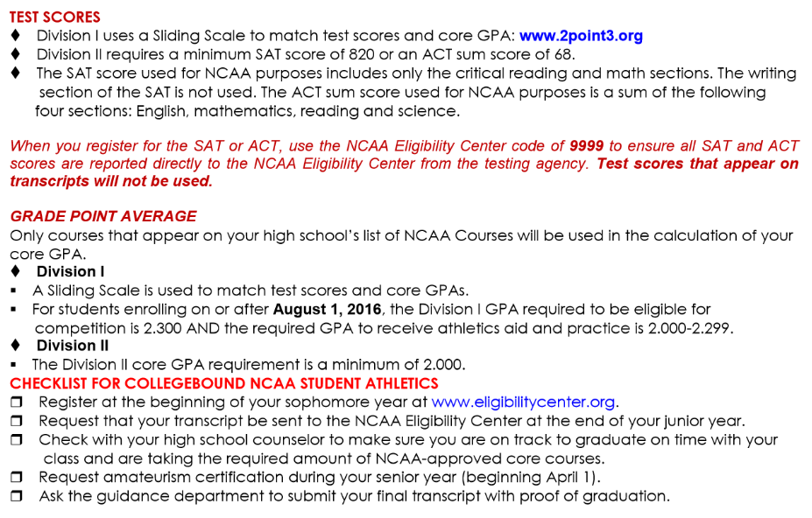
BRIGHT FUTURES SCHOLARSHIPS OFFERED BY THE STATE OF FLORIDA
There are three scholarship awards under the title of Florida Bright Futures. The following is a list of the current requirements. For the latest information you can call 1-888-827-2004 or visit the home page at http://www.floridastudentfinancialaid.org/. A student may qualify for all three award levels but may only receive the highest one earned. The requirements below are for the Class of 2022 High School Graduates and beyond and are subject to change with each legislative session.
Specific Requirements for the Florida Academic Scholars (FAS) and Florida Medallion Scholars (FMS) Bright Futures awards:
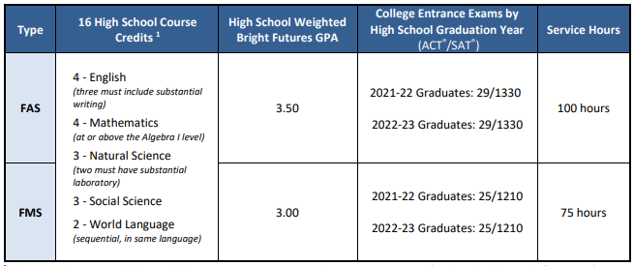Specific Requirements for the Gold Seal Vocational (GSV) Bright Futures awards:
Type | Core Course Requirements | High School Weighted GPA | College Entrance Exams | Service Hours
GSV | 4 – English  4 – Math  3 – Science  3 – Social Science  1 – Fine or Practical Art | 3.0 | SAT Reading 24/ Writing 25/ Math 24  ACT Reading 19/English 17/ Math 19  PERT Reading 106/Writing 103/ Math 114 | 30 Hours
 |  | Unweighted GPA in 3 VOC Courses
 |  | 3.5

Gold Seal CAPE Scholars (GSC) The Florida Gold Seal CAPE Scholars award (GSC) may be funded if enrolled in a career education or certificate program.
The Florida Gold Seal CAPE Scholars award (GSC) may be funded if a student is enrolled in a career education or certificate program. Upon completion of an associate in science degree program that articulates to a Bachelor of Science degree, a GSC Scholar may also receive an award for a maximum of 60 credit hours toward a Bachelor of Science degree program. Upon completion of an associate in applied science program, a GSC Scholar may also receive an award for a maximum of 60 credit hours toward a bachelor of applied science degree program.
Florida high school students who wish to qualify for the GSC award must meet the following initial eligibility requirements:
• Earn a minimum of five postsecondary credit hours through CAPE industry certifications that articulate for college credit; and
• Complete 30 service hours.

DUAL ENROLLMENT CRITERIA

Wakulla High School dual enrollment students must demonstrate a readiness for college or career level course work; be seeking a vocational certificate, a college credit vocational/technical certificate, an associate in science college degree, or an associate in arts college degree; and be classified as a high school junior or senior or have demonstrated academic, social and emotional maturity to ensure success in college level study. WHS offers dual enrollment in partnership with Tallahassee Community College, Florida State University, and Lively Technical Center.
TCC Dual Enrollment
A secondary student must meet the following requirements in order to be eligible to participate in the High School Dual Enrollment Program at Tallahassee Community College:
- Have a minimum 3.0 unweighted cumulative GPA
- Online courses or courses located at Tallahassee Community College cannot be taken if the same course is offered at Wakulla High School
- Maintain a "C" or better in each class to remain in the dual enrollment program
- Be aware that receiving a "W", "D" or an "F" for any course may result in ineligibility to remain in the dual enrollment program, which will be defined in the Wakulla High School and Tallahassee Community College 2021-2022 articulation agreement
- Provide acceptable results from the American College Test (ACT), the Scholastic Aptitude Test (SAT), the PERT or another standardized placement test for college level English and Math:
 | English/Verbal | Reading/Writing | Math: MAC 1105 | Math: MAT 1033
ACT | 17 | 19 | 21 | 19-20
SAT | 440 |  | 470 | 440-469
PERT |  | 106/103 | 123 | 114-122

FSU Dual Enrollment
A secondary student must meet the following requirements in order to be eligible to participate in the High School Dual Enrollment Program at Florida State University:
- Must be a secondary student with a 3.9 weighted high school GPA on a minimum of 12 graded credits to include:
  - 2 English credits
  - 2 mathematics credits, one of which must be Algebra II or higher
  - 1 science credit with lab
  - 1 social studies credit
- Must meet any course prerequisites as set forth in the University undergraduate catalog, and transcript must show proof of credit for prerequisite course requirements to enroll, if applicable.
- Students who have earned a semester grade below a C in any high school course are not eligible, regardless of GPA.
- A 3.0 FSU GPA is required for students to continue in the High School Dual Enrollment Program at Florida State University.
- Must have all the following standardized test subscores:
 | English | Reading | Math
ACT  Composite 26 | 19 | 19 | 21
 | Writing | Reading | Math
SAT  Composite 1230 | 27.5 | 24.5 | 25.5

Lively Technical - Career Dual Enrollment
A secondary student must meet the following requirements in order to be eligible to participate in the High School Dual Enrollment Program at Lively Technical Center:
- Have a minimum 2.0 unweighted cumulative GPA
- Be 16 years old
- Participate in the TABE test

TCC DUAL-ENROLLMENT
WAKULLA HIGH SCHOOL ON-CAMPUS COURSE OFFERINGS

ENC 1101 College Composition  CREDIT: 1.0 in English GRADE: 11-12  Prerequisite: See dual-enrollment section for test score and GPA information. “A” in English II or “B” in English II Honors and passing score on the FSA Grade 10 or concordant score. | ENC 1102 Argument and Persuasion  CREDIT: 1.0 in English GRADE: 11-12  Prerequisite: See dual-enrollment section for test score and GPA information. “A” in English II or “B” in English II Honors and passing score on the FSA Grade 10 or concordant score.
LIT 2000 Introduction to Literature  CREDIT: 1.0 in English GRADE: 12  Prerequisite: See dual-enrollment section for test score and GPA information. A, B, or C in ENC1101. | ENL 2000 British Literature  CREDIT: 1.0 in English GRADE: 12  Prerequisite: See dual-enrollment section for test score and GPA information. A, B, or C in ENC 1101 and ENC 1102.
SLS 1510 College Success  CREDIT: 0.5 in Elective GRADE: 10-12  Prerequisite: See dual-enrollment section for test score and GPA information. | HUN 1201 Science of Nutrition  CREDIT: 0.5 in Elective GRADE: 12  Prerequisite: See dual-enrollment section for test score and GPA information. A, B, or C in ENC 1101 and ENC 1102.

AP COURSES
COLLEGE BOARD ADVANCED PLACEMENT
The Advanced Placement Program® is a cooperative educational endeavor between secondary schools and colleges and universities. Since its inception in 1955, the Program has provided motivated high School students with the opportunity to take college-level courses in a high school setting. Students who participate in the Program not only gain college-level skills, but in many cases they also earn college credit by scoring a 3 or higher on the AP exam at the end of the course. AP courses are taught by dedicated and enthusiastic high school teachers who follow course guidelines developed and published by the College Board. All AP courses are 5.0 weighted courses. The AP exam score is not part of the student’s classroom grade. For more information on our AP Program, visit or contact Student Services. The College Board recognizes students each year who successfully pass three or more Advanced Placement Exams each year. (www.bigfuture.org)
AP students should expect to:
- Do approximately 30-60 minutes of homework each night for each AP course
- Be absent from school only when absolutely necessary
- Grow and be challenged intellectually
- Think critically
- Solve difficult and meaningful problems
- Reach the highest level of self-efficacy.
ADVANCED PLACEMENT COURSES AVAILABLE AT WAKULLA HIGH SCHOOL
Core | Available Electives
9th Grade
No available courses | AP Art History  AP Human Geography
10th Grade
AP World History | AP Art History  AP Human Geography  AP Music Theory
11th Grade
AP English Language and Composition  AP U.S. History  AP Statistics  AP Environmental Science | AP Art History  AP Human Geography  AP Music Theory
12th Grade
AP Literature or AP English Language  AP Calculus or AP Statistics  AP Biology or AP Environmental Science | AP Art History  AP Human Geography  AP Music Theory
SUBJECT AREA COURSES

LANGUAGE ARTS
English I (1001310) GRADE: 9  CREDIT: 1.0  This course provides instruction in English language skills including reading, writing, speaking, and listening in the content areas of literature and language. Earning a credit in this course precludes the earning of credit in English Honors I. | English I Honors (1001320) GRADE: 9  CREDIT: 1.0  This course promotes academic excellence in English language arts through enriched experiences in literature, writing, speaking, and listening. Earning a credit in this course precludes earning of credit in English I.  Prerequisite: Teacher recommendation and FSA ELA Level 4-5
English II (1001340) GRADE: 10  CREDIT: 1.0  This course provides instruction in English language skills and in the study of world literature. Earning a credit in this course precludes earning a credit in English Honors II. | English II Honors (1001350) GRADE: 10  CREDIT: 1.0  This course promotes academic excellence in English language arts through the study of world literature and through enriched experiences in composition, speech, and listening skills. Students enrolled in this  course will obtain skills needed to be successful in Advanced Placement Language.  Prerequisite: “B” in English I OR “C” in English I Honors OR FSA ELA Level 4 -5
English III (1001370) GRADE: 11  CREDIT: 1.0  The purpose of this course is to provide grade 11 students, using texts of high complexity, integrated language arts study in reading, writing, speaking, listening, and language for college and career preparation and readiness. | English III Honors (1001380) GRADE: 11  CREDIT: 1.0  The purpose of this course is to provide grade 11 students, using texts of high complexity, advanced integrated language arts study in reading, writing, speaking, listening, and language in preparation for college and career readiness.  Prerequisite: FSA ELA Grade 10 Level 3-5
English V (1001400)  CREDIT: 1.0 GRADE: 12  The purpose of this course is to provide grade 12 students, using texts of high complexity, advanced integrated language arts study in reading, writing, speaking, listening, and language for college and career preparation and readiness. | English IV Honors (1001410)  CREDIT: 1.0 GRADE: 12  The purpose of this course is to provide grade 12 students, using texts of high complexity, advanced integrated language arts study in reading, writing, speaking, listening, and language for college and career preparation and readiness.  Prerequisite: “B” in English III or “C” in English III Honors and a passing score on FSA ELA Grade 10

AP English Language Arts Courses
*Teacher Recommendation Required*  AP English Language and Composition (1001420) CREDIT: 1.0 GRADE: 11-12 This course will provide students with an understanding of the semantic, structural, and rhetorical resources of the English language as they relate to the principles of effective writing. In addition to earning high school credit, students may earn college credit if the proficiency level is met on the National Advanced Placement exam.  Prerequisite: “B” in English II Honors or “A” in English II | *Teacher Recommendation Required*  AP English Literature and Composition (1001430)  CREDIT: 1.0 GRADE: 10-12  This course covers college material in British literature. In addition to earning high school credit, students may earn college credit if the proficiency level is met on the national AP exam.  Prerequisite Grade 10: FSA ELA Level 5 and “A” or “B” in Eng 1  Prerequisite Grade 11-12: “A” in English II/III, “B” in English II/ III Honors, “C” in AP English Language

LANGUAGE ARTS ELECTIVES
Creative Writing I (1009320)  CREDIT: .5 GRADE: 9-12  The purpose of this course is to enable students to develop and use grade 9-10 writing and language skills for creative expression in a variety of literary forms. Studying and modeling a variety of genres will be emphasized at this level of creative writing.  Also fulfills Performing Arts credit. | Creative Writing II (1009330)  CREDIT: .5 GRADE: 9-12  The purpose of this course is to enable students to develop and use grade 11-12 writing and language skills for creative expression in a variety of literary forms. Studying and modeling a variety of genres will be emphasized at this level of creative writing.  Also fulfills Performing Arts credit.
Debate 1 (1007330)  CREDIT: 1.0 GRADE: 9-12  The purpose of this course is to develop students’ beginning awareness, understanding, and application of language arts as it applies to oral communication concepts and strategies for public debate in a variety of given settings.  Also fulfills Performing Arts credit. | Speech 1 (1007300)  CREDIT 1.0 GRADE 9-12  The purpose of this course is to develop students' beginning awareness, understanding, and application of language arts as it applies to oral communication concepts and strategies in a variety of given settings.  Also fulfills Performing Arts credit.
Journalism 1 (1006300)
CREDIT: 1.0 GRADE:9-12
The purpose of this course is to enable students to develop fundamental skills in the production of journalism across print, multimedia, web, and broadcast/radio platforms and to develop knowledge of journalism history, ethics use, and management techniques related to the production of journalistic media.
Also fulfills Performing Arts credit.

MATHEMATICS

Algebra I-A (1200370) GRADE: 9  CREDIT: 1.0 Math  The purpose of this course is to provide the foundation for more advanced mathematics courses and to develop the skills needed to solve mathematical problems. This is Part 1 of 2 courses that combined meet the State of Florida graduation requirement for algebra. | Algebra I-B (1200380) GRADE: 9 - 10  CREDIT: 1.0 Algebra  The purpose of this course is to provide the foundation for more advanced mathematics courses and to develop the skills needed to solve mathematical problems. This is Part 2 of 2 courses that combined meet the State of Florida graduation requirement for algebra.  EOC determines 30% of student grade; must pass for graduation
Algebra I (1200310) GRADE: 9  CREDIT: 1.0 Algebra  The purpose of this course is to provide the foundation for more advanced mathematics courses and to develop the skills needed to solve mathematical problems. This course meets the State of Florida graduation requirement for Algebra.  EOC determines 30% of student grade; must pass for graduation | Mathematics for College Liberal Arts (1207350) GRADE: 11  CREDIT: 1.0  The purpose of this course is to analyze and apply linear and exponential functions within a real-world context, utilize geometric concepts to solve real-world problems, extend understanding of probability theory, and develop understanding of logic and set theory.  (Note: This course is geared for the student who needs additional work in Algebra I before going on to Algebra II.)
Geometry (1206310) GRADE: 9-10  CREDIT: 1.0  The purpose of this course is to develop the geometric relationships and deductive strategies which can be used to solve a variety of real-world and mathematical problems. Earning a credit in Geometry precludes earning a credit in Geometry Honors. This course meets the State of Florida graduation requirement for Geometry.  EOC determines 30% of student grade | Geometry Honors (1206320) GRADE: 9-10  CREDIT: 1.0  The purpose of this course is to provide a rigorous, in-depth study of geometric relationships and deductive strategies which can be used to solve a variety of real-world and mathematical problems. Earning a credit in Geometry Honors precludes earning a credit in Geometry. This course meets the State of Florida graduation requirement for Geometry.  Prerequisite: "B" in Algebra I or Algebra 1-B or "C" or higher in Algebra I Honors and teacher recommendation.  EOC determines 30% of student grade
Algebra II (1200330) GRADE: 9-12  CREDIT: 1.0  The purpose of this course is to continue the study of algebra and to provide the foundation for applying algebraic skills to other mathematical and scientific fields. Earning a credit in Algebra II precludes earning a credit in Algebra II Honors.  Prerequisite: "C" or higher in Geometry or MFCR. | Algebra II Honors (1200340) GRADE: 9-12  CREDIT: 1.0  The purpose of this course is to present an in-depth study of the topics of Algebra II with emphasis on theory, proof, and development of formulas. Topics include those of Algebra II (see above) but in more detail. Earning a credit in Algebra II Honors precludes earning a credit in Algebra II.  Prerequisite: “B” in Geometry or “C” in Geometry Honors and teacher recommendation.

Mathematics Courses cont.
Probability and Statistics Honors (1210300)  CREDIT: 1.0 GRADE: 10-12  This course provides an elementary introduction to probability and statistics with applications. Topics include: basic principles of design, analysis and discussion of various types of data, random variables, probability distributions, hypothesis testing, confidence intervals, and linear regression. | Mathematics for Data and Financial Literacy (1200387)  CREDIT: 1.0 GRADE: 11-12  The purpose of this course is to extend knowledge of ratios, proportions and functions to data and financial contexts, develop understanding of basic economic and accounting principles, determine advantages/disadvantages of credit accounts and short/long term loans, develop understanding of planning for the future through investments, insurance and returement plans, and to extend knowledge of data analysis to create and evaluate reports and make predictions.  Prerequisite: Algebra 1 and Geometry
Mathematics for College Algebra (1200700)  CREDIT: 1.0 GRADE: 11-12  The purpose of this course is to develop fluency with the Laws of Exponents with numberical and algebraic expressions, extend arithmetic operations with algebraic expressions, solve one-variable exponential, logarithmic, radical and rational equations and interpret the viability of solutions in real-world contexts, and model/apply various types of equations and functions to real-world examples.  Prerequisite: Algebra 1 and Geometry | Pre-Calculus (1202340)  CREDIT: 1.0 GRADE: 10-12  The purpose of this course is to enable students to develop concepts and skills in advanced algebra, analytic geometry, and trigonometry.  Prerequisite: "B" or higher in Algebra II or “C” or higher in Algebra II Honors and teacher recommendation.
AP Mathematics Courses
AP Calculus AB (1202310) BC (1202320)  CREDIT: 1.0 GRADE: 11- 12  The purpose of this course is to study algebraic and transcendental functions and the general theory and techniques of calculus.  In addition to earning high school credit, students may earn college credit if the proficiency level is met on the national AP exam.  Prerequisite: “B” or higher in Pre-Calculus. Teacher recommendation only. | AP Statistics (1210320)  CREDIT: 1.0 GRADES: 11-12  The purpose of the AP course in statistics is to introduce students to the major concepts and tools for collecting, analyzing, and drawing conclusions from data.  In addition to earning high school credit, students may earn college credit if the proficiency level is met on the national AP exam.  Prerequisite: “B” or higher in previous Math course. Teacher recommendation required.

SCIENCE

Integrated Science 2 (2002420) GRADE: 9
CREDIT: 1.0
This course provides introductory instruction for the high school series of physical and biological sciences. Students will investigate basic chemistry, physics, and biology concepts through instruction and inquiry based activities.
Physical Science (2003310) GRADE: 9 -11  CREDIT: 1.0  This course includes dynamics, classification and interaction of matter, periodic table, forms of energy, electricity and magnetism, chemical interactions, nuclear reactions and career opportunities in physical science. Earning a credit in this course precludes the earning of credit in Physical Science Honors. | Physical Science Honors (2003320) GRADE: 9 - 11  CREDIT: 1.0  The purpose of this course is to provide students with an investigative study of the theories and laws associated with the natural physical and chemical properties of nature. Earning a credit in this course precludes earning a credit in Physical Science.
Biology (2000310) GRADE: 9 - 10  CREDIT: 1.0  The purpose of this course is to provide exploratory experiences and laboratory and real-life applications in the biological sciences.  Prerequisite: Physical Science OR at least a “B” in Integrated Science OR a Level 3-5 FCAT Science.  EOC determines 30% of student grade | Biology I Honors (2000320) GRADE: 9 -10  CREDIT: 1.0  This course teaches traditional biology for those going to a four year university. Earning a credit in Biology I Honors precludes earning a credit in Biology.  Prerequisite: “B” in Physical Science or “C” or higher in Physical Science Honors OR an “A” in Integrated Science and Level 4 - 5 FCAT Science.  EOC determines 30% of student grade
Chemistry I (2003340) GRADE: 11-12  CREDIT: 1.0  The content includes composition, properties, and changes associated with matter. Earning credit in Chemistry I precludes earning a credit in Chemistry I Honors.  Prerequisite: Completion of Algebra I and Biology. | Chemistry I Honors (2003350) GRADE: 11-12  CREDIT: 1.0  The purpose of this course is to provide students with a rigorous study of the composition, properties, and changes associated with matter. Earning a credit in Chemistry I Honors precludes earning a credit in Chemistry I.  Prerequisite: Completion of Algebra I and Biology with a "B" or higher and teacher recommendation.
Environmental Science (2001340) GRADE: 11-12  CREDIT: 1.0  This course provides students with a study of the effects of technology on air, water, and land quality, including conservation and pollution control.  Prerequisite: Completion of Biology. | Marine Science (2002500) GRADE: 11-12  CREDIT: 1.0  While the content focus of this course is consistent with the Marine Science I course, students will explore these concepts in greater depth. In general, the academic pace and rigor will be greatly increased for honors level course work. Laboratory investigations that include the use of scientific inquiry, research, measurement, problem solving, laboratory apparatus and technologies, experimental procedures, and safety procedures are an integral part of this course.  Prerequisite: “C” or better in Biology.

AP Science Courses
*Teacher Recommendation Required*  AP Biology (2000340) GRADE 11-12  CREDIT: 1.0  This course is a college level Biology course that explores Genetics, Taxonomy, Botany, Human Biology and Environmental Science.  In addition to earning high school credit, students may earn college credit if the proficiency level is met on the national AP exam.  Prerequisite: “B” or higher in Biology. “B” or higher in Chemistry. | *Teacher Recommendation Required*  AP Environmental Science (2001380) GRADE: 11-12  CREDIT 1.0  The goal of the AP Environmental Science course is to provide students with the scientific principles, concepts, and methodologies required to understand the interrelationships of the natural world, to identify and analyze environmental problems both natural and human-made, to evaluate the relative risks associated with these problems, and to examine alternative solutions for resolving and/or preventing them.  In addition to earning high school credit, students may earn college credit if the proficiency level is met on the national AP exam.  Pre-Requisite or Co-Requisite: Chemistry

SOCIAL SCIENCE

World History (2109310) GRADE: 10  CREDIT: 1.0  A multi-dimensional survey of World History concepts in the areas of geography, economics, religion, government, technology, and social issues from the pre-historic period through World War II. Earning a credit in this course precludes the earning of a credit in World History Honors or AP World History. | World History Honors (2109320) GRADE: 10  CREDIT: 1.0  This course covers world history from the pre-historic period through World War II. Earning a credit in this course precludes the earning of a credit in World History or AP World History.  Prerequisite: “B” in English I or “C” in English I Honors.
U. S. History (2100310) GRADE: 11  CREDIT: 1.0  This course is the study of the economic, geographical, political, and social development of the American nation. Earning credit in this course precludes the earning of credit in American History Honors.  EOC determines 30% of student grade. | U. S. History Honors (2100320) GRADE: 11  CREDIT: 1.0  This course is in-depth, analytical study of the economic, geographical, political, and social development of the American nation. Earning a credit in this course precludes the earning of credit in American History.  Prerequisite: “B” or better in World History or “C” or better in World History Honors.  EOC determines 30% of student grade.
American Government (2106310)  CREDIT: .5 GRADE: 12  The content of this course includes a view of Anglo-American political history and thought, the Constitution, the branches of government, political parties and politics, domestic and foreign policy, and  the rights and responsibilities of the people. Earning a credit in this course precludes earning a credit in American Government Honors or AP American Government. | American Government Honors (2106320)  CREDIT: .5 GRADE: 12  This course gives students an opportunity to learn about the American government and the political process. It includes an overview of: American political history and thought, the Constitution, the branches of government, political parties and politics, domestic and foreign policy, and the rights and responsibilities of the people. Earning a credit in this precludes earning a credit in American Government or AP American Government.  Prerequisite: “B” or better in American History or a “C” or better in American History Honors or AP U.S. History.

Social Science Courses cont.
Economics with Financial Literacy (2102335)  CREDIT: .5 GRADE: 12  The content includes the study of the way in which society organizes its limited resources to satisfy unlimited wants, the similarities and differences of economic systems, and the use of economic reasoning in reaching decisions. Earning a credit in this course precludes the earning of a credit in Economics Honors. | Economics Honors with Financial Literacy (2102345) CREDIT: .5 GRADE: 12  The content includes economics theories and principles which students apply in learning to understand how different societies organize and utilize limited resources to satisfy unlimited wants. Earning a credit in this course precludes the earning of a credit in Economics.  Prerequisite: “B” or better in American History or “C” or better in American History Honors or AP U.S. History.
AP and Pre-AP Social Science Courses
*Teacher Recommendation Required*  AP World History (2109420) GRADE: 10-12  CREDIT: 1.0  This course explores the development of Europe within the context of history by examining connections to the past in order to prepare for the future as participating members of a global community. Students use knowledge pertaining to history, geography, economics, political processes, religion, ethics, diverse cultures and humanities to solve problems in academic, civic, social and employment settings. Earning a credit in this course precludes the earning of a credit in World History or World History Honors.  In addition to earning high school credit, students may earn college credit if the proficiency level is met on the national AP exam.  Prerequisite: “A” in English I or “B” in English I Honors. | *Teacher Recommendation Required*  AP U.S. History (2100330) GRADE: 11-12  CREDIT: 1.0  This course explores the development of the U.S. by examining connections to the past to prepare for the future. Students use knowledge pertaining to history, geography, economics, political processes, religion, ethics, diverse cultures and humanities to solve problems in academic, civic, social and employment settings. Earning a credit in this course precludes the earning of credit in American History or American History Honors.  In addition to earning high school credit, students may earn college credit if the proficiency level is met on the national AP exam.  Prerequisite: “A” in World History or “B” in World History Honors/ AP World History.
*Teacher Recommendation Required*
Pre-AP World History (2109415) Grade: 9 CREDIT: 1.0
This course prepares students for the rigor and scope of AP World History. Students will use knowledge pretaining to history, geography, economics, political processes, religion, eithics, diverse cultures and humanitites to solve problems in academic, civic, social and employment settings. Students who participate in this class and pass with a “B” or higher will be recommended for AP World History.
***Passing this course or any exam attached to the course does not award college credit***

SOCIAL SCIENCE ELECTIVES
Florida History (2100350) GRADE: 9-12  CREDIT: .5  The grade 9-12 Florida History course consists of the following content area strands: World History, American History, Geography, Humanities, Civics and Government. The primary content emphasis for this course pertains to the study of the chronological development of the state of Florida by examining the political, economic, social, military and cultural events that affected the state. | Sociology (2108300) GRADE: 9-12  CREDIT .5  Through the study of sociology, students acquire an understanding of group interaction and its impact on individuals in order that they may have a greater awareness of the beliefs, values and behavior patterns of others. In an increasingly interdependent world, students need to recognize how group behavior affects both the individual and society.
Psychology 1 (2107300)  CREDIT: .5 GRADE: 9-12  Through the study of psychology, students acquire an  understanding of and an appreciation for human  behavior, behavior interaction and the progressive  development of individuals. The content examined in  this first introductory course includes major theories  and orientations of psychology, psychological  methodology, memory and cognition, human growth  and development, personality, abnormal behavior,  psychological therapies, stress/coping strategies, and  mental health. | Psychology 2 (2107310)  CREDIT: .5 GRADE: 9-12  Through the study of psychology, students acquire an understanding of and an appreciation for human behavior, behavior interaction and the progressive development of individuals. The content examined in this second introductory course includes statistical research, psychobiology, motivation and emotion, sensation and perception, states of consciousness, psychological testing, and social psychology.
Holocaust History Honors (2100405)  CREDIT: .5 GRADE: 9-12  The grade 9-12 Holocaust course consists of the  Following content area strands: American History,  World History, Geography, Humanities, Civics and  Government. The primary content emphasis for this course pertains to the examination of the events of the Holocaust (1933-1945), the systemic, planned annihilation of European Jews and other groups by Nazi Germany. | Personal Financial Literacy (2102372)  CREDIT: .5 GRADE: 9-12  This grade 9-12 course consists of the following  content area and literacy strands: Economics,  Financial Literacy, Mathematics, Languages Arts for  Literacy in History/Social Studies and Speaking and  Listening. Basic economic concepts of scarcity, choice,  opportunity cost, and cost/benefit analysis are  interwoven throughout the standards and objectives. Emphasis will be placed on economic  decision-making and real-life applications using real  data.
AP Social Science Elective | Law Studies (2106350 ) GRADE: 9-12  CREDIT: .5  The Law Studies course consists of: American History,  World History, Geography, Humanities, Economics,  and Civics and Government. The primary content for  the course pertains to the study of the American legal  system as the foundation of American society by  examining those laws which have an impact on  citizens' lives and an introduction to fundamental civil  and criminal justice procedures. Content includes, but  is not limited to, the need for law, the basis for our legal  system, civil and criminal law, adult and juvenile courts,  family and consumer law, causes and consequences of  crime, individual rights and responsibilities, and career  opportunities in the legal system.
*Teacher Recommendation Required*

AP Human Geography (2106420 ) GRADE: 9-12
CREDIT: .5
The AP Human Geography course introduces students
to the systematic study of patterns and processes that
have shaped human understanding, use, and alteration of Earth’s surface.
In addition to earning high school credit, students may
earn college credit if the proficiency level is met on the
national AP exam.

FINE AND PERFORMING ARTS

AP Performing Arts Courses
*Teacher Recommendation Required*  AP Art History (0100300) GRADE: 9-12  CREDIT: 1.0  The purpose of this course is to introduce students to the appreciation of various works of art while cultivating the ability to critically analyze the intentions of the artists and patrons. Students examine major forms of artistic expression in the Western tradition, beyond the Western tradition on up to current trends in Global art.  In addition to earning high school credit, students may earn college credit if the proficiency level is met on the national AP exam.  Application required. | *Teacher Recommendation Required*  AP Music Theory (2101300) GRADE 10-12  CREDIT: 1.0  This course develops the student’s ability to recognize and understand the basic materials and processes in any music that is heard or read in score.  In addition to earning high school credit, students may earn college credit if the proficiency level is met on the national AP exam.  Application required.  Extracurricular participation is required.
Art Electives
Draw I (0104340) GRADE: 9-12  Draw II (0104350) CREDIT: 1.0  Draw III (0104360)  These course provide students with opportunities to develop basic drawing and painting skills while strengthening their visual perceptions, understanding and appreciation of art. This is achieved by studying master artists throughout history from many cultures. Sketchbook must be purchased. | Portfolio Development: GRADE: 11-12 Drawing Honors (0109310) CREDIT: 1.0  Students work in a self-directed environment to develop a portfolio showing a body of their own work that visually explores a particular artistic concern, articulated and supported by a written artist's statement. Artists may work in, but are not limited to, content in drawing, painting, printmaking, and/or mixed media that emphasizes line quality, rendering of form, composition, surface manipulation, and/or illusion of depth.  Teacher recommendation required.
3D Studio Art 1
GRADE: 9-12 CREDIT: 1.0
Students explore how space, mass, balance, and form combine to create aesthetic forms or utilitarian products and structures. Instruction may include, but is not limited to, content in green or industrial design, sculpture, ceramics, or building arts. Media may include, but are not limited to, clay, wood, plaster, and paper maché with consideration of the workability, durability, cost, and toxicity of the media used.
Chorus, Band, and Music Electives
Chorus I (1303300) GRADE: 9-12  Chorus II (1303310) CREDIT: 1.0  These beginning-level courses are for students interested in vocal music performances. The following musical skills for ensemble singing will be stressed: proper breathing, pleasant vocal production, blend and balance, expansion of range, good intonation, ear training, and sight-reading. Participation in various performance opportunities is a requirement of the class. | Music of the World (1300340) GRADE 9-12  CREDIT: 1.0  The purpose of this course is to enable students to develop the knowledge and skills necessary to understand and appreciate how music is used in one’s personal life as well as in varied cultures, societies, and historical periods.
Chorus III (1303320) GRADE: 9-12  Chorus IV (1303330) CREDIT: 1.0  This year-long, formative class, designed for students with previous participation in a school chorus who have basic knowledge of note-reading and vocal technique, concentrates on providing students opportunities to strengthen existing skills in critical listening, vocal techniques, and ensemble performance using high-quality three- and four-part choral literature. Rehearsals focus on gaining independence in music literacy and aesthetic engagement through critical listening and thinking skills.  Prerequisite: Chorus II | Guitar I (1301320) GRADE 9-12  Guitar II (1301230) CREDIT: 1.0  The purpose of this course is for students with little or no experience to develop basic guitar skills and knowledge, including simple and full-strum chords, bass lines and lead sheets, barre and power chords, foundational music literacy and theory, major scales, simple finger-picking patterns, and ensemble skills for a variety of music.
Eurhythmics I (1305300) GRADE: 9-12  CREDIT: 1.0  This course provides students participating in marching band flag and dance with instruction in the development of skills in the art of performing various bodily movements in rhythm using musical accompaniment. Course content will include music terminology, note values, rhythms, meter, tempo, melodic content and contrast, music listening, performance techniques, choreography, costuming and makeup, and safety practices.  Prerequisite: Teacher recommendation required.  Extracurricular participation is required. | Instrumental Techniques I (1302420) GRADE 11-12  CREDIT: 1.0  Emphasizing performance techniques, music knowledge, critical analysis, and aesthetic response, this course enables students to develop basic performance skills on a selected instrument in a solo or small ensemble setting.  Prerequisite: Teacher recommendation required.
Band I (1302300) GRADE: 9-12  Band II (1302310) CREDIT: 1.0  Band III (1302320)  Band IV (1302330)  This course provides students with opportunities to develop musicianship skills in band and instrumental ensembles. Performance course.  Prerequisite: Teacher recommendation required.  Extracurricular participation is required. | Jazz Ensemble I (1302500) GRADE: 9-12  Jazz Ensemble II (1302510) CREDIT: 1.0  Jazz Ensemble III (1302520)  Jazz Ensemble IV (1302530)  The purpose of this course is to provide an introduction to styles and performance techniques of representative contemporary popular music and jazz literature.  Prerequisite: Teacher recommendation required.
Theatre Electives
Theatre I (0400310) GRADE: 9-12  Theatre II (0400320) CREDIT: 1.0  These courses are designed for students ranging from little or no theatre experience to intermediate skills to promote enjoyment and appreciation for all aspects of theatre. | Tech Theatre I (0400410) GRADE: 10-12  Tech Theatre II (0400420) CREDIT: 1.0  Tech Theatre III (1007300)  The purpose of this course is to introduce students to the fundamentals of technical theatre and enable students to develop basic skills in stagecraft and apply them through practical experiences.  Prerequisite: Theatre I and/or teacher recommendation.
Theatre III Honors (0400330) GRADE: 11-12  Theatre IV Honors (0400340) CREDIT: 1.0  These courses provide opportunities for drama students to continue study in acting and production techniques. Emphasis is given to acting theories, set design, make-up and lighting.  Prerequisite: "B" or better in previous Theatre II and IIIcourses and teacher recommendation. | Acting II (0400380) GRADE: 9-12  Acting III (0400390) CREDIT: 1.0  Acting IV (0400400)  These courses provide students the opportunity to create characters for theatrical and film/video productions through scene, character, and technical analysis. Through improvisation, script writing, and aesthetic creation and collaboration, actors refine their working knowledge and independent thought, articulating and justifying their creative choices. Students’ “critical eye” becomes more developed and significant mastery of artistic choices becomes evident.  Teacher recommendation required.

WORLD LANGUAGES

Spanish I (0708340) GRADE: 9-11  Spanish II (0708350) CREDIT: 1.0  This course reinforces fundamental skills and develops increased listening, speaking, reading, and writing skills as well as cultural awareness.  Prerequisite: "C" or better in English. | French I (0701320) GRADE 9-11  French II (0701330) CREDIT: 1.0  CONTENT: French 1 introduces students to the target language and its culture. The student will develop communicative skills in all 3 modes of communication and cross-cultural understanding. Emphasis is placed on proficient communication in the language. An introduction to reading and writing is also included as well as culture, connections, comparisons, and communities.

PHYSICAL EDUCATION

Personal Fitness (1501300) GRADE: 9-12
CREDIT: .5
This course provides students with opportunities to develop an individual optimal level of physical fitness, acquire knowledge of physical fitness concepts and the significance of lifestyle on one's health and fitness.
*** Required for graduation.
Weight Training I (1501340) CREDIT: .5  Weight Training II (1501350)  Weight Training III (1501360) | Tennis I (1504500) CREDIT: .5  Tennis II (1504510)
Aerobics I (1503400) CREDIT: .5  Aerobics II (1503410)  Aerobics III (1503420) | Team Sports I (1503350) CREDIT: .5  Team Sports II (1503360)
* Athletes should contact their coach for required recommendation before selecting PE course. | Basketball (1503310) CREDIT: .5

GENERAL ELECTIVES

ACT and SAT Prep Course  Critical Thinking and Study Skills (1700370)  CREDIT: .5 GRADE: 9-12  This course is designed to develop skills related to critical thinking, learning and problem solving, enabling students to enhance their performance in both academic and non-academic areas. Strategies for acquiring, storing and retrieving information, time management and organizational skills, critical thinking operations and processes, strategies for oral and written communication, and problem solving skills including test taking skills are an integral part of this course. | Executive Internship I (0500300)  CREDIT: 1.0 GRADE: 10-12  The purpose of this course is to provide a practical introduction to the work environment through direct contact with professionals in the community.  Teacher request/approval only.
Research I (1700300)  CREDIT: 1.0 GRADE: 11-12  Minimum GPA of 3.0  Application Required | Research III (1700320)  CREDIT: 1.0 GRADE: 11-12  Minimum GPA 2.5  Application Required

INTENSIVE AND OTHER REQUIRED COURSES
Intensive Reading I & II (1000412 & 100414)  CREDIT: 1.0 GRADE: 10-12  Special Notes: Administrative Placement  • Placement will be made after careful evaluation of the student’s academic history.  • Intensive Reading will primarily focus on fluency, vocabulary, and comprehension strategies through the use of flexible small group instruction and guided and independent practice. | Foundational Skills in Mathematics  CREDIT: 1.0 GRADE: 9-12  Special Notes: Administrative Placement  • Placement will be made after careful evaluation of the student’s academic history.  • Foundational Skills in Mathematics will primarily focus on comprehension strategies through the use of flexible small group instruction and guided and independent practice.
Freshman Seminar/AVID 1 GRADE 9 Required Course  CREDIT: 1.0  In their Freshman Seminar course, students will closely read high-interest articles and develop skills for breaking down and coding challenging text. In organized classroom discussions, such as the Socratic Seminar, students will hone their academic conversational skills by defending their ideas with textual evidence and logical reasoning. Finally, students will respond to the reading’s essential question through text-based writing strategies. | Credit Recovery/ Research (1700300)  CONTENT: Student works independently on computer to meet academic standards of selected course. Student is required to keep documentation of computer time and activities.

COLLEGE AND CAREER PROGRAMS OF STUDY

Aerospace Technologies
The purpose of this program is to prepare students for employment and advanced educational training in the emerging aviation industry of unmanned aircraft systems (UAS). Instruction is designed to prepare students for Federal Aviation Administration (FAA) ground school examinations for Private Pilot rating. The dual enrollment portion of this course will be conducted in partnership with Embry-Riddle Aeronautical University.
COURSES
Aerospace Technologies 1 (8600580)
Aerospace Technologies 2 (8600680)
Aerospace Technologies 3 (8600780)
Principles of Aeronautical Science (ASC1000)
Unmanned Aircraft Systems (ASC2560)
Industry Certifications
Small unmanned Aircraft Systems Safety Ground Certification
Visual Line-of-Sight Systems Operator
FAA Part 107, Remote Pilot’s License and Private Pilot Ground Certification

Engineering Academy | Medical Academy
The Engineering Academy requires a prerequisite of Algebra I, Algebra I Honors, one science course and/or teacher recommendation. These courses do not fulfill Gold Seal Bright Futures requirements, but does prepare them for dual enrollment engineering courses. Students must apply for admission. Enrollment is limited; all students may not be accepted.  Prerequisite: Algebra I, Digital Information Technology, and teacher recommendation.  Engineering Technology  This program provides students with the knowledge, human relations and technological skills found today in technical professions.  COURSES  Introduction to Engineering Design Honors (8600550)  Principles of Engineering Honors (8600520)  Engineering Design and Development Honors (8600650)  Industry Certification  Autodesk Certified User—Inventor | The academy includes a rigorous academic and career-focused curriculum. Select core academic courses are integrated with courses in the career area. Enrollment in the academy is open for the first course. Students must apply for admission to the Health Science courses. Enrollment is limited; all students may not be accepted.  Pre/co-requisite: Digital Information Technology  Nursing Assistant Acute and Long Care  This program is designed to prepare students for employment or advanced training in a variety of health occupations.  COURSES  Principles of the Biomedical Sciences Honors (8708110) GRADE: 9  This course provides students with practical generic skills in health occupations Students completing or enrolled in this course may apply to enter the Medical Academy in 10th grade.  Health Science Anatomy and Physiology Honors (8417100)  Health Science Foundations Honors (8417110)  Nursing Assistant (8417211) or Health and Wellness (8417000)  Industry Certification  Emergency Medical Responder  Certified Nursing Assistant

AVID | ROTC
This course is designed to prepare students to succeed in a rigorous high school curriculum that will prepare them for college. It offers support through academic instruction, tutorial sessions, and motivational activities. This course is for students committed to improving their potential for educational success who otherwise might not have taken Honors, Advanced Placement, and Dual Enrollment courses without this program. COURSES  AVID I (1700390)  AVID II (1700400)  AVID III (1700410)  AVID IV (1700420)  Prerequisite: Application and committee Selection. 9th grade.  Co-requisite: Enrollment in honors courses. | This course introduces students to the Naval Junior Reserve Officers Training Corps Program, a citizenship program for high school students in the ninth through twelfth grades. The course is designed to develop personal, academic, and leadership skills essential for college and professional careers. Leadership, self-reliance, self-discipline, goal setting, and communication skills are emphasized. JROTC encourages students to become involved, informed and responsible members of the community. COURSES  Naval Science I (1802300)  Naval Science II (1802310)  Naval Science III (1802320)  Naval Science IV (1802330)  Boot Camp is strongly encouraged, but is not required.  Extracurricular participation is required.
Arts Technology & Communication
Digital Design
This program prepares students for careers involving word processing, digital publishing, graphic design
and multimedia designers.
COURSES
Digital Information Technology (8207310)
Digital Design 1 (8209510)
Digital Design 2 Honors (8209520)

Industry Certification
Adobe Certified Associate
Microsoft Office Specialist
Cosmetology | Hospitality & Tourism
Cosmetology  This program prepares students for further education and careers in the Human Services career cluster. The content includes communication, leadership, human relations and employability skills, safe and efficient work practices, and Florida cosmetology law and rules.  COURSES  Grooming and Salon Services Core 1 (8757210)  Facials Specialty 2 (8757410)  Facials Specialty 3 (8757420) | Culinary Arts  This program is designed to prepare students for careers in many areas related to Food Services, such as restaurant services, nutrition and hospitality.  COURSE  Culinary Arts 1 (8800510)  (1 Period/ 1 credit/ year-long)  Culinary Arts 2 (8800520)  (2 Periods/ 1 credit/ semester-long)  Intro to Food Prep (HMV0101)  (2 Periods/ 1 credit/ semester-long)  Industry Certification  Certified Food Protection Manager (ServSafe)

Architecture & Construction | Air Conditioning, Refrigeration and Heating Technology
This program prepares students for employment as carpenters, carpenter helpers, rough carpenters or maintenance carpenters. Content includes communication skills, leadership skills, human relations and employability skills, safe and efficient work practices, basic trade skills, laying out, fabricating, erecting, installing and repairing residential wooden structures and fixtures using hand and power tools.  COURSES  Building Trades & Construction Design Tech 1 (8722010)  (1 Period/ 1 credit/ year-long)  Building Construction Asst (BCV0080)  (2 Periods/ 2 credits/ year-long)  Carpentry and Masonry Tech (BCV0081)  (2 Periods/ 1 credit/ semester-long)  Electrical and Plumbing Tech (BCV0082)  (2 Periods/ 1 credit/ semester-long) | This program prepares students to identify, use, and maintain the tools and tool accessories used in the heating, air-condition, and refrigeration industry. Students will learn to fabricate and service the piping, tubing, and fittings used in the heating, air-condition, and refrigeration industry. Students will gain knowledge of electricity and the electrical components of heating, air-conditioning and refrigeration equipment.  COURSES  Air Conditioning, Refrigeration & Heating Tech 1 &2 (8713010 and 8713020)  Air Conditioning, Refrigeration & Heating Tech 3 & 4 (8713030 and 8713040)  Air Conditioning, Refrigeration & Heating Tech 5 & 6 (8713050 and 8713060)  Air Conditioning, Refrigeration & Heating Tech 7 (8713070)
Transportation, Distribution, Logistics | Manufacturing
Automotive Service Technology  This program is designed to prepare students for employment or advanced training in the automotive technical field.  Student is required to be 16 years old or to have completed ninth grade to participate in Automotive Program.  Prerequisite: 2.5 GPA and the TABE test.  COURSES  Maintenance and Light Repair 1 & 2 (AER0025 & AER0026 )  (2 Periods/ 2 credits/ year-long)  Maintenance and Light Repair 3 & 4 (AER0027 & AER0028)  (2 Periods/ 2 credits/ year-long)  Industry Certification  ASE-Auto Maintenance and Light Repair | Applied Welding Technologies  This program is designed to give a broad foundation of knowledge and skills to prepare students for employment in applied welding positions.  Student is required to be 16 years old or to have completed ninth grade to participate in Welding Program.  Prerequisite: 2.5 GPA and the TABE test.  COURSES  Welding Technologies 1 & 2 (9204410 and 9204420)  (2 Periods/ 2 credits/ year-long)  Welding Assistant 1 & 2 (PMT0070 and PMT0071)  (2 Periods/ 2 credits/ year-long)  Industry Certification  AWS Certified Welder
Phlebotomy
The purpose of this program is to prepare students for employment as phlebotomists. Phlebotomists are specialized healthcare workers who collect blood samples from patients. This is a one-year program.
Basic Healthcare Worker (HSC0003)
Phlebotomist (MEA0520)
Student is required to be 16 years old.
Industry Certification
Certified Phlebotomy Technician (CPT)

ACCESS COURSES
Access courses are intended only for students with a significant cognitive disability. Access courses are designed to provide students with access to the general curriculum. Access points reflect increasing levels of complexity and depth of knowledge aligned with grade-level expectations. The access points included in access courses are intentionally designed to foster high expectations for students with significant cognitive disabilities.
ACCESS English 1/11 (7910111) | ACCESS English III/IV (7910112)
ACCESS Information Geometry (7912060) | ACCESS Mathematics for College Liberal Arts
ACCESS Algebra IA (7912080) | ACCESS Algebra 1B (7912090)
ACCESS Integrated Science 1 (7920025) | ACCESS Biology (7920015)
ACCESS Earth/Space Science (7920020) | ACCESS World History (7921027)
ACCESS US History (7921025) | ACCESS Algebra 1B (7912090)
ACCESS Economics (7921020) | ACCESS U.S. Government (7921015)
ACCESS Personal Fitness (7915020) | ACCESS Visual and Performing Arts (7967010)

